**MOMENTUM ACADEMY BOARD OF DIRECTORS**

**MINUTES OF AN EXECUTIVE SESSION MEETING OF THE BOARD**

**March 24, 2025**

**Location : Zoom**

[**https://us06web.zoom.us/j/87684777124?pwd=8biDB2Sddm86ghcm50OSm1excaXgFg.1**](https://us06web.zoom.us/j/87684777124?pwd=8biDB2Sddm86ghcm50OSm1excaXgFg.1)

**Board Members Present:** David Simmons, Kathy Kirk,Patrick Davis, Melissa Powers, Courtney Stevenson, Hanley Chiang, Nilesh Patel, Brittany Kelleher, Brandi Chin, and Theresa Yoffie

**Board Members not Present:**

**Guests present:** Antionette Bedessie

|  |  |
| --- | --- |
| **Topic (Presenter)** | **Updates, Decisions, and Action Items** |
|  | At7:58 p.m., Mr. David Simmons called the meeting to order. |
| Executive Session | Motion to move into Executive Session Mo. Rev. Stat. §610.021(13) for discussion of Dr. Miranda Ming’s performance review and bonus and 2nd. Roll call vote unanimously passed. |
| Action | Discussion and review of Dr. Miranda Ming’s performance conducted. Motion to approve Dr. Miranda Ming’s bonus. Seconded and passed. |
| Adjournment | At 8:41 p.m., a motion to adjourn the Executive session of the meeting and go back into open session by David Simmons and 2nd. Roll call vote unanimously passed. |

Respectfully submitted by Kathy Kirk, Secretary.

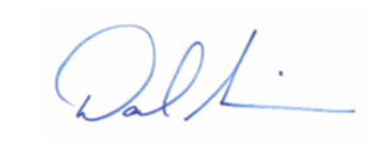 3/25/25

___________________________________ _________________________

David Simmons, President Date



3/24/25

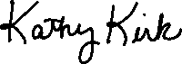

____________________________________ __________________________  
  
Kathy Kirk, Secretary Date